                  ONLINE SHOPPING

NOTE:

The user here is **ADMIN.**

**The Database Tables used here are,**

1. **Product Table:** Contains Product information.

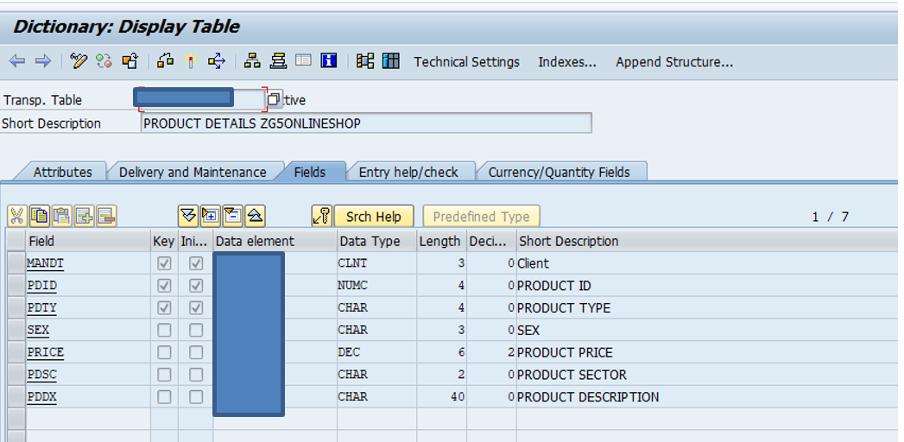

1. **Inventory Table:** Contains product sizes and their stocks information.

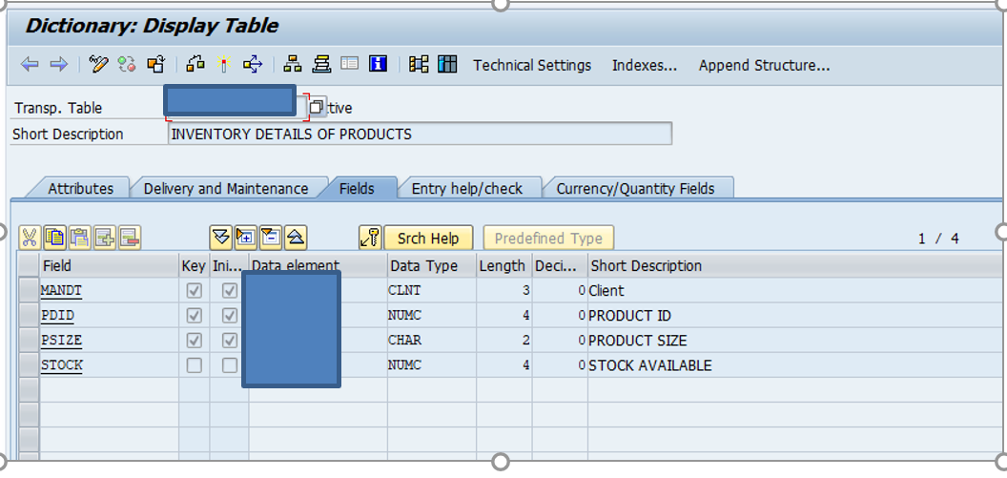

1. **Order History Table:** Contains order History Information.

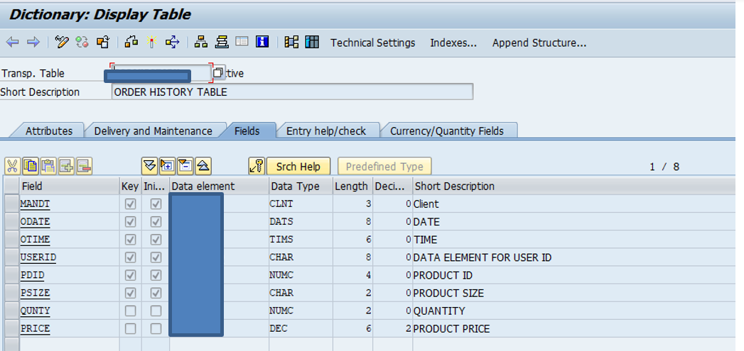

**Functionalities**:

1. **ADMIN LOGIN:** Login screen appears where the user enters the login ID and password.

**Case 1:** Either incorrect login Id or incorrect password.

Then it displays a pop up message saying **“INVALID ID/PASSWORD”.**

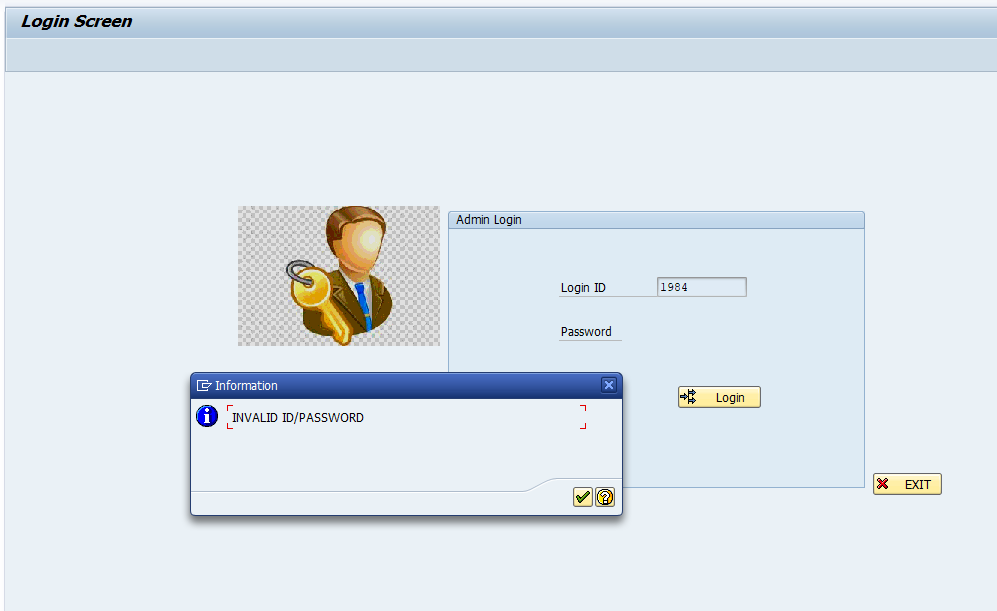

**Case 2 :** Enters the correct credentials.

Then it takes to Admin Functionalities screen .

**EXIT :** The user clicks the exit button, when he/she doesn’t want to login.

1. **ADMIN FUNCTIONALITIES :**

This is the screen that appears after admin logins, which displays the functionalities a admin can perform.

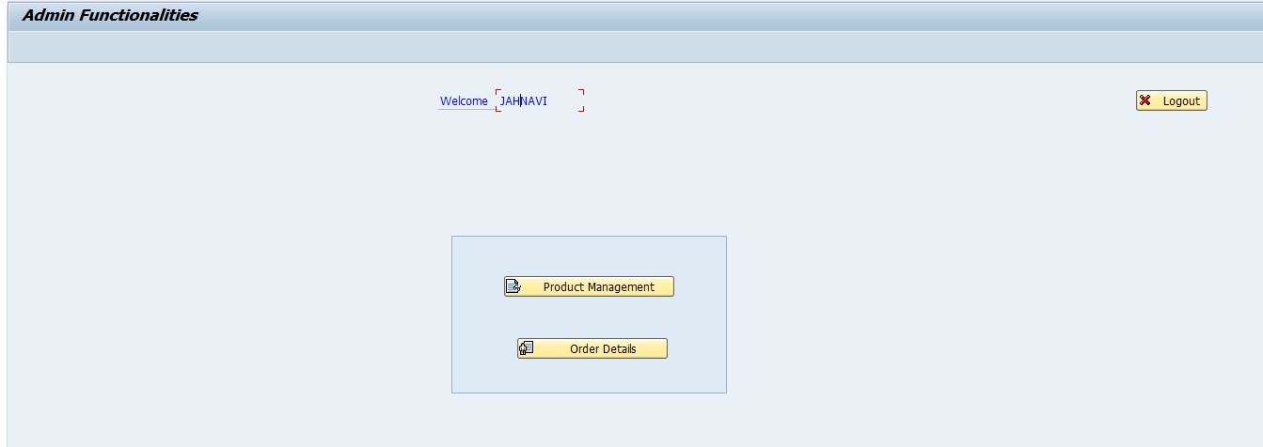

**Case 1 :** When admin selects the Product Management button.

Then it takes to the Product screen which displays all the available products.

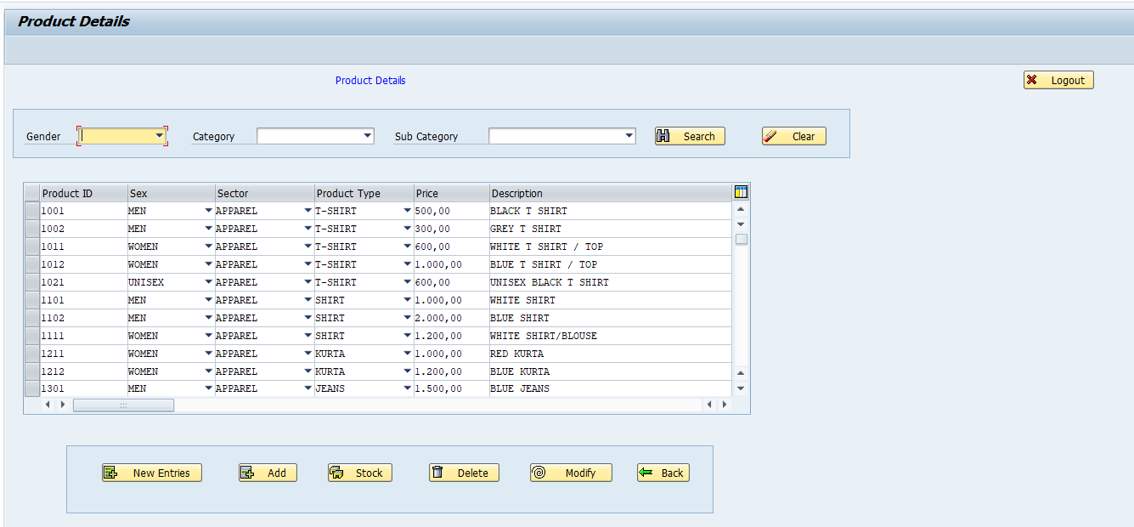

**Functionalities in Product Management**

**1) New-Entries** : When the user(admin)clicks the new entries button it appends an empty line to the internal table (which I used to display products). Later user enters the details of the product he/she wants to add and then clicks the ADD button.

**2) ADD** : After the clicking the add button , it checks whether the Product ID already exists or not.

**Case 1**: Product ID is already used before.

Then it displays a pop up message saying **“ PRODUCT ID ALREADY EXISTS”**.

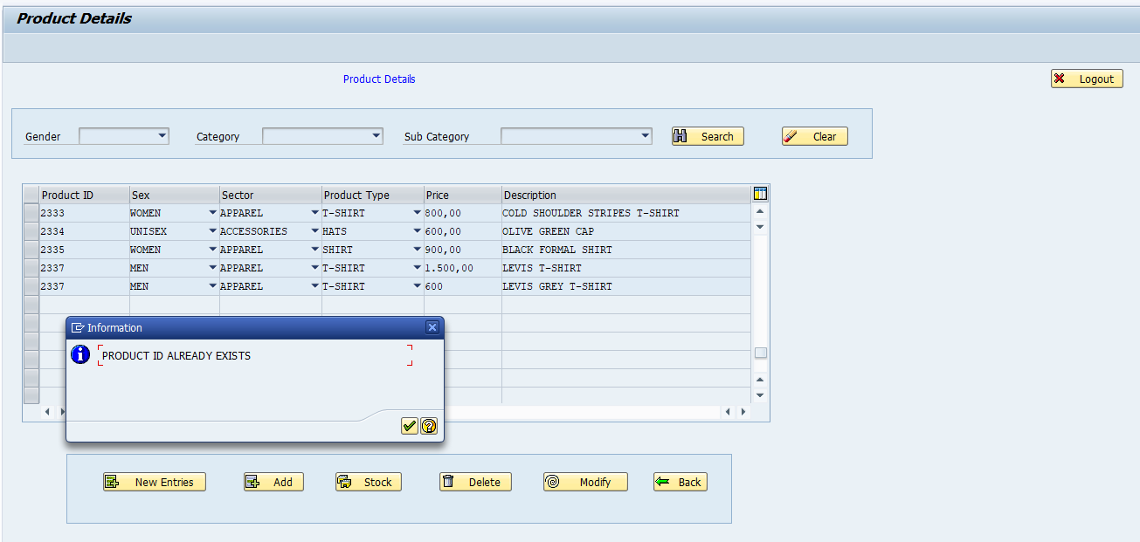

**Case 2:** Product ID is not used before.

Then it takes to inventory screen , asking to fill the size and stock details.

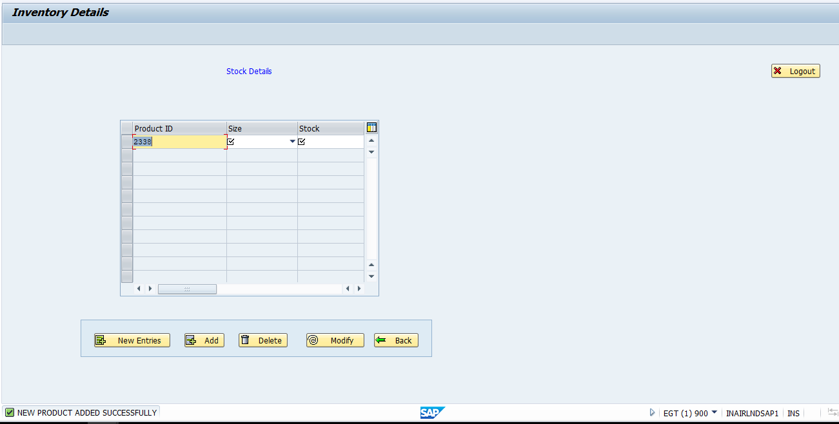

Later fills the required fields and clicks the ADD button. When the data is successfully stored , it dislays a pop up message saying **“STOCK ADDED SUCCESSFULLY”.**

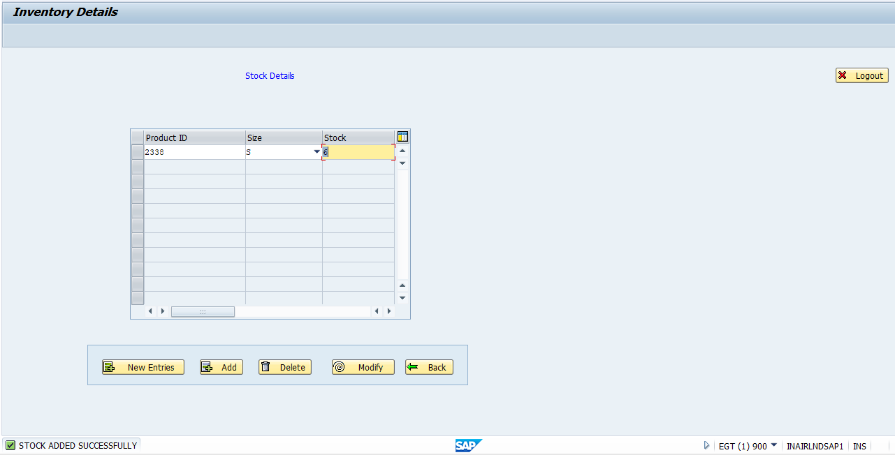

Press Back Button to go to Product screen.

**3) DELETE :** To Perform the delete operation the user should select a row (the particular product he/she wants to delete). Selects any product and clicks delete button , Then that particular product and its corresponding sizes and stock are also deleted. After successful deletion, it displays a message **“ PRODUCT DELETED SUCCESSFULLY”.**

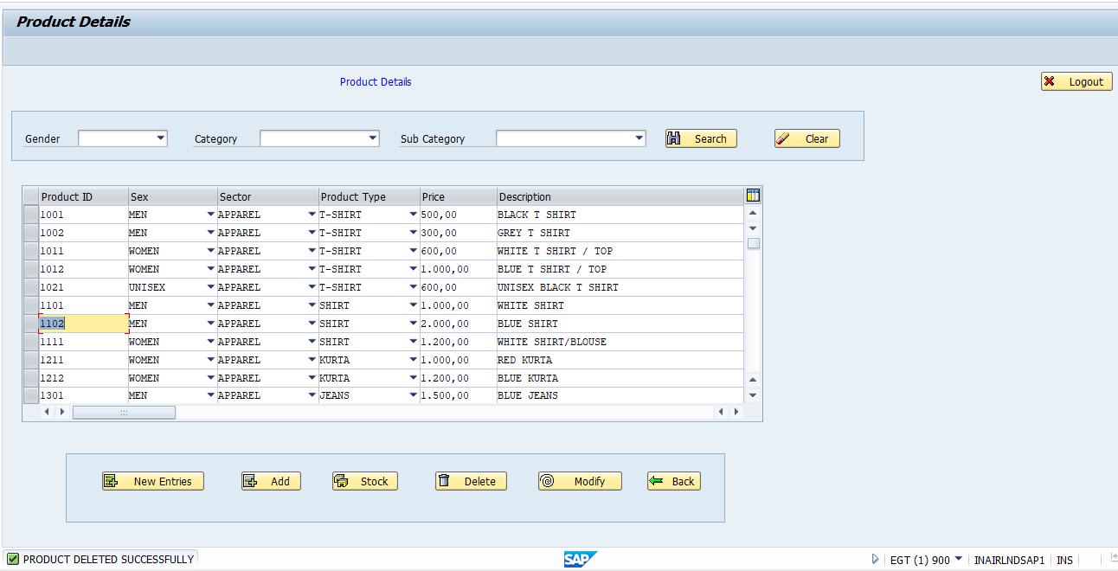

**4) MODIFY:** To Perform the modify operation the user should select a row (the particular product he/she wants to modify). Selects any product and does the modifications (like updating price or description) and clicks Modify button , Then that particular product is Modified. After successful modification, it displays a message **“ PRODUCT UPDATED SUCCESSFULLY”.**

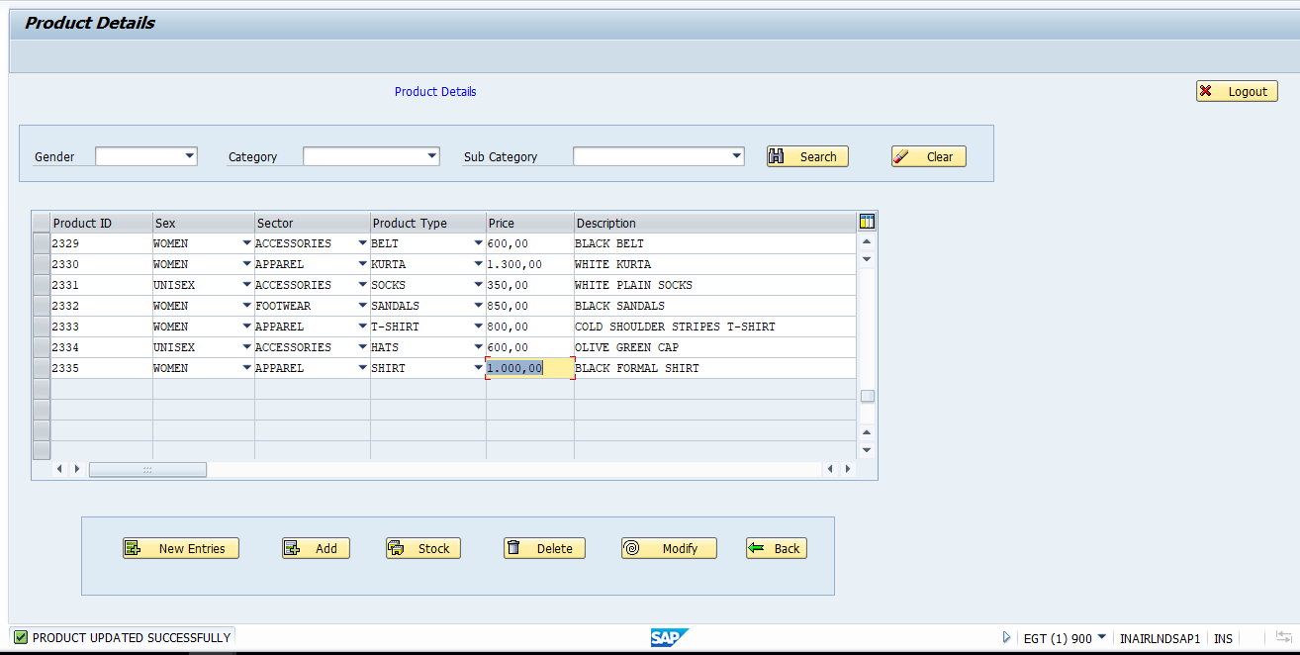

**5) STOCK :** To Perform the stock operation the user should select a row (the particular product he/she wants to view the stock). Selects any product and clicks Stock button, then the inventory screen opens which displays the available sizes and their stocks of the selected product. The Buttons in that screen are **New-Entries, ADD, Delete, Modify** whose functionalities are same as discussed above.

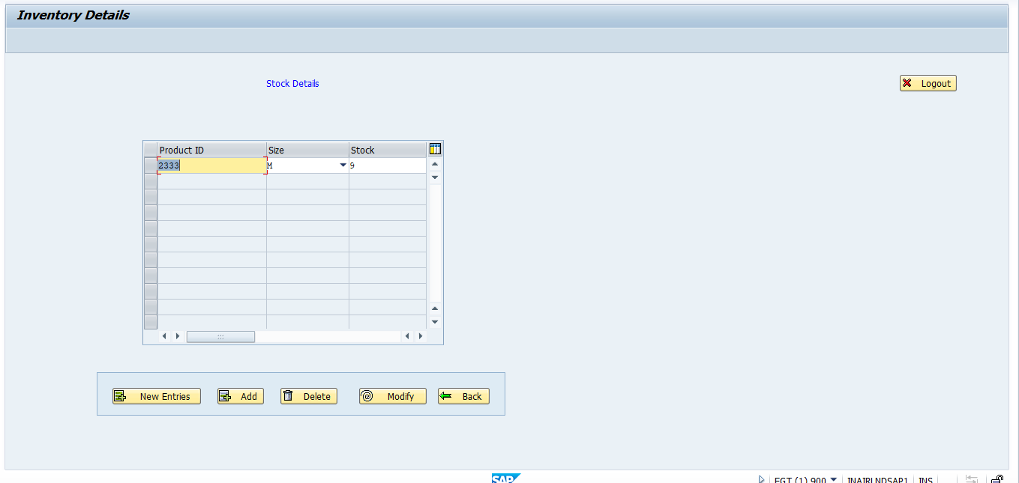

**Delete –** Deleting all the available sizes, deletes that product.

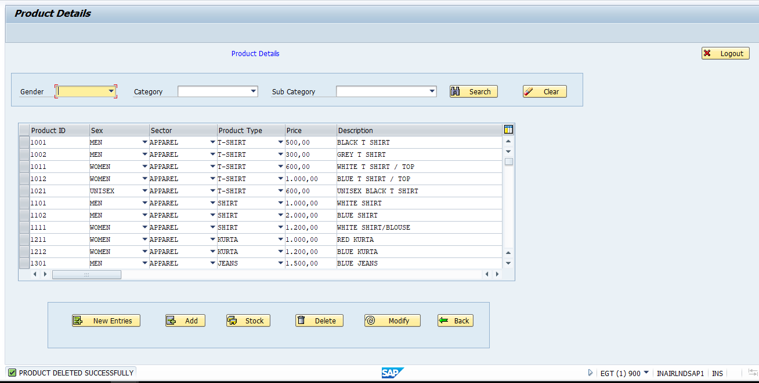

**6) SERACH :** The Product screen at first displays all the available products.

**Case 1:** User selects a gender from the drop down (women, men, unisex) and clicks search.

Then all the products with that gender are displayed.

**Case 2:** User selects a gender from the drop down (women, men, unisex) ,and selects the category from drop down(apparel, footwear, accessories) and clicks search .

Then all the products with gender and category are displayed.

**Case 3:** User selects a gender from the drop down (women, men, unisex) ,and selects the category from drop down(apparel, footwear, accessories) and and selects the subcategory from drop down (which displays the corresponding product types based on gender and category selected) and clicks search .

Then all the products with gender, category and subcategory are displayed.

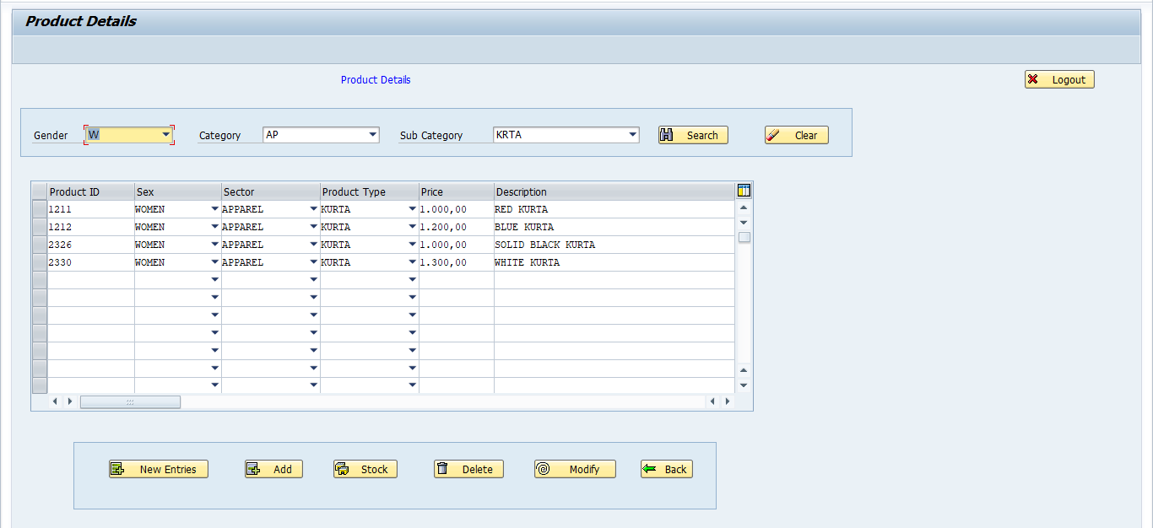

**7) CLEAR:** When the user clicks the Clear button, it erases all the searched options and displays all the products.

**Case 2 :** When admin selects the Order Details button.

Then it takes to the Order Details screen which displays all the order details placed by the all customers latest by date.

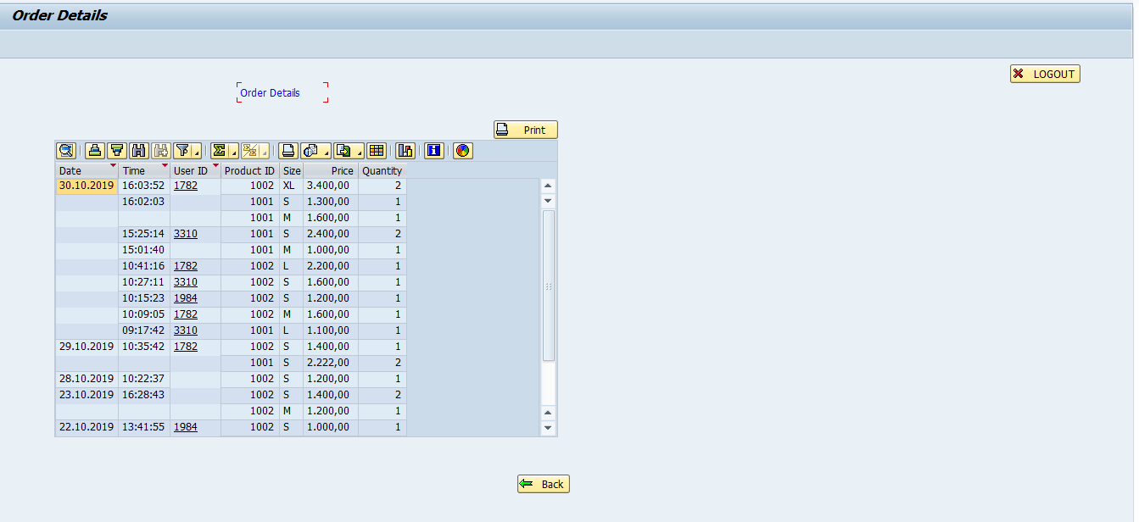

When the user double clicks on the user ID, then a dialog screen appears which displays those particular customer personal details (user id, first name, last name, email id).

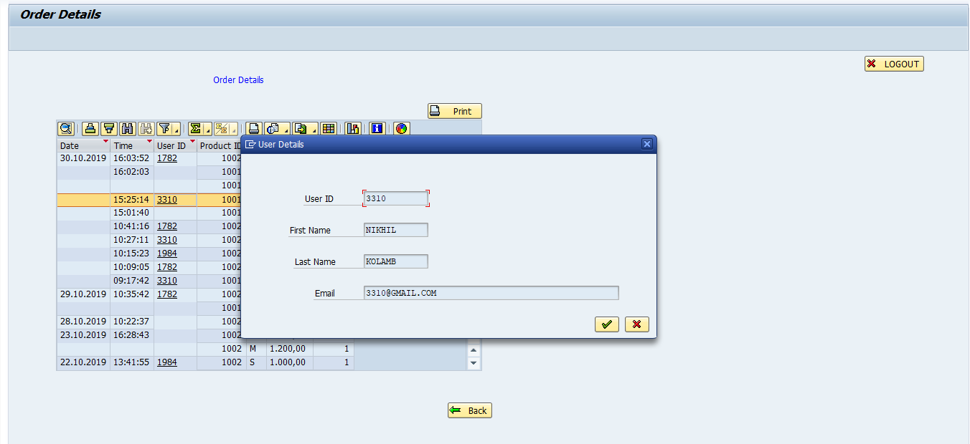

**PRINT:** When the user clicks the print button, the order details history is printed in a pdf format. It can be used for further reference.

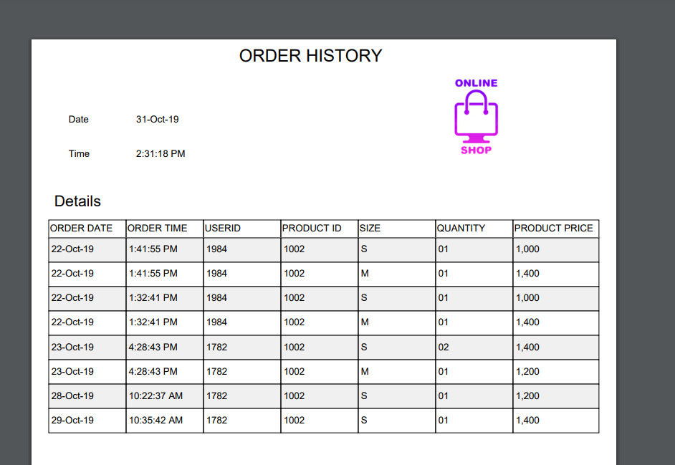

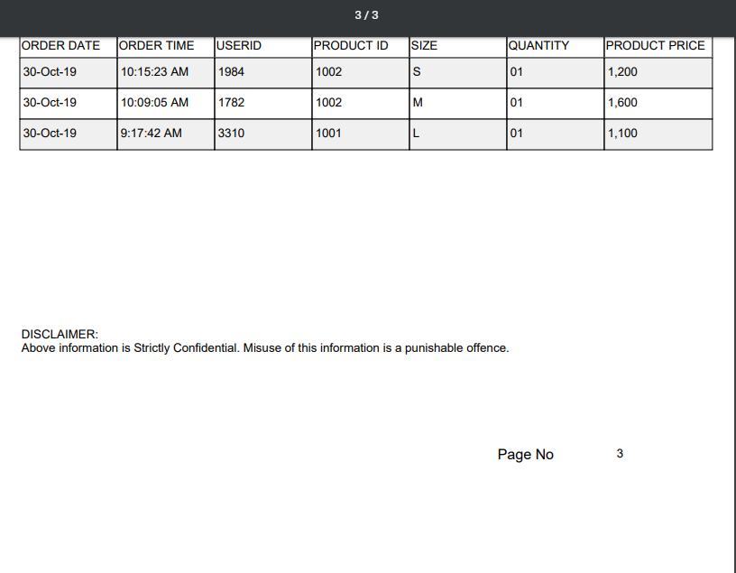

**BACK:** When the user clicks the back button, it goes to the previous screen.

**LOGOUT:** When the user clicks the logout button, it goes back to the login screen.

Back and logout buttons functionality is same as mentioned above wherever it appears.